Food Order App

Rivier University
CS552BH1: Object-Oriented System Analysis & Design
Summer 2016, Term-1
Submitted to: Brian Lopez

Submitted by:
Chaitrali Jayantilal Doshi
Mili Bhargava
Vineel Sai Kumar Rampally
Pavan Koppula

Executive Summary

Introduction
Food Order App is a mobile application for ordering food online from various restaurants. This platform will provide a convenient way to browse through the different restaurant menus and order without going to their individual sites.

Goal
The goal of this application is to avoid user’s efforts by providing single platform to browse and order from nearby restaurants.

Overview
- A user will have an account for the mobile app service.
- It will have menus from restaurants that have subscribed to this service.
- A user can browse through different menus and place an order.
- The customer has an option to pay the bill using the app itself or pay on delivery.
- The order will be placed at a restaurant nearest to the customer and the subscribed delivery service will be notified. For delivering food charges will be applied. Also User has option for Order to pick up or order to Delivery.
- An agent from the delivery service will pick up the order and deliver it to the customer.

Table of Contents

Food Order App 1
1 Executive Summary 2
1.1 Introduction 2
1.2 Goal 2
1.3 Overview 2
2 Project Plan 4
2.1 Implementation plan 4
2.2 Testing Plan 5
3 Functional Specification 6
3.1 Requirements 6
3.2 Assumption and constraints 6
3.3 Use Case Diagram 7
3.4 Activity Diagram 13
3.5 Sequence Diagram 16
3.6 Class Diagram 17
3.7 Object Diagram 18
3.8 State Machine Diagram 19
4 Functional Test Plan 20
4.1 Login test case for both User and Restaurant Panel 20
4.2 Test Case for Admin Panel 20
4.3 Test Case for User Panel 21
4.4 Test Case for Restaurant Panel 22
5 System Design Specifications 23
5.1 System Physical Architectural 23
5.2 Package Diagram 24
5.3 UI Design 25
5.4 Window Navigation Diagram 27
6 Database Structure 28
6.1 Table Structure 28
6.2 ER Diagram 29
7 System Integration Test Plan 30
8 Issues for future studies 30
9 Conclusion 31
10 References 31

Project Plan
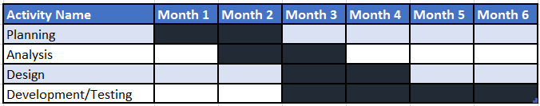
Above diagram shows estimated project plan.

Implementation plan
Food Order app will have the majorly three modules
- Admin (System Admin)
- User (Customer)
- Client (Restaurant Owner)
These three modules have different types of the specification and requirements. Clients and User have features common as the registration and login and forget password other requirements are changed based on the type of login. If the login person is Admin, then the person has the features like approval orders. If the login person is User then he has the features like search store, create order, bill for order, get delivered give feedback of the Restaurants. The following table illustrates that how much time it will take to the complete the each and every requirement. This task estimation is only to implement the requirements not for quality analysis. Here I will describe if three people are working parallel.
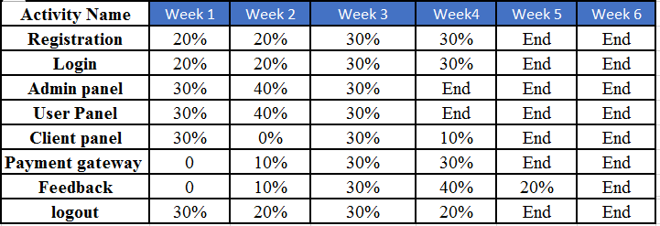

The above table gives a clear idea about our starting and end of the each and every requirement.

Testing Plan
Testing plan will include various phases as below,
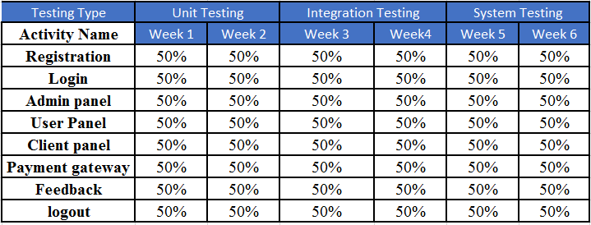

Functional Specification

Requirements
- User Registration: The user will have to create an account for using the app. For creating an account user will need to create User-Id and Password. Once the user has created an account, then he/she can order food from available restaurants menu’s.
- Payment Method: The user has multiple payment option like Pay online and Cash on Delivery. For paying online, you can either pay with a Credit card or Debit Card. Also card information can be stored for future use on request.
- Restaurants Registration: Restaurants will have to fill out registration form, which will ask for Name of restaurant, Its menu and other information for ordering food from that restaurant.
- Delivery System: Once the order has been placed, the notification will go to the restaurant as well as Delivery Services. Delivery system will notify their nearest driver to pick food from the restaurant and deliver it to the customer. If payment method is Cash on Delivery, then Driver will collect money as per receipt.

Assumption and constraints
- The app should be available on the phone.
- Restaurant will be registered for the app service.
- Delivery service has a contract with the App service and restaurants.
- The selected restaurants should be within the range of delivery service.
- The order cancelation is solely at the discretion of the restaurant.
- The order should be placed at least 30 minutes before restaurant closing time.

Use Case Diagram
This will include 3 use case diagrams for the system.
- User Registration and Order
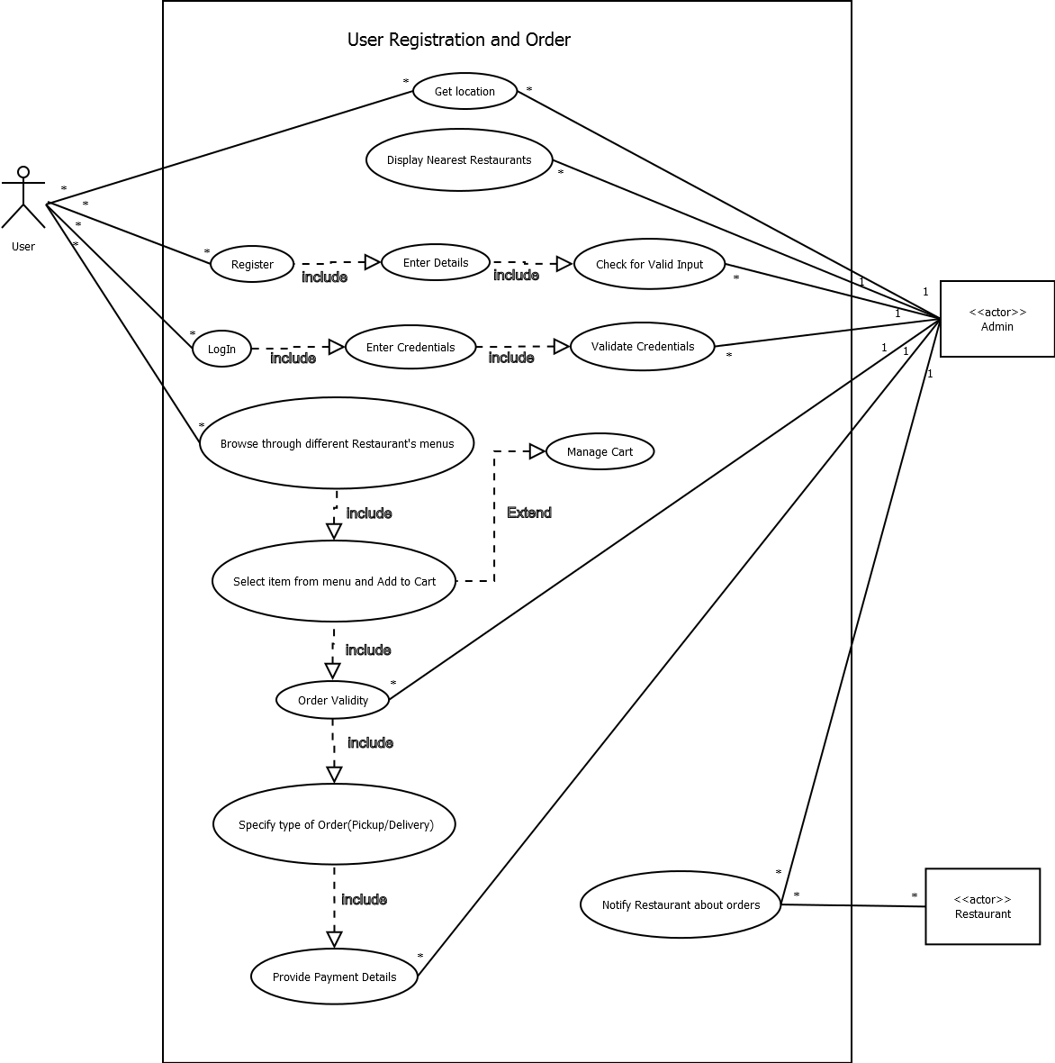

Use Case Description for User Registration & Order:
Use Case Name: | User Registration & Order
ID: | UC_1
Actors: | User, Admin, Restaurant
Description: | The user logs in using this app and orders food from the nearest restaurant.
Trigger: | The user must be an existing one or properly registered in the case of new user to place the order.
Relationships: | Association: User, System, App
Normal Flow of Events: | - The user will be displayed the nearest restaurants based on his/her location.  - A new user will register on the app or an existing user will log in to order food.  - The credentials will be validated by the system.  - User will select an item from menu.  - Items will be added or deleted from the cart.  - User will provide payment details for the transaction.  - The order will be validated by the system; first, whether the order is placed at least 30 minutes before restaurant closing time; second, the type of order whether it’s a pickup or delivery; and third, for checking whether the selected restaurant is within the range of delivery service (in case of delivery order).  - Final order will be placed.
Exceptions: | 2a. If the credentials are invalid, the user will enter the login / register details again.  - The selected item must be available.  - If the order is out of range of the delivery service or the order is placed less than 30 min of the restaurant closing time, the order will be discarded.  6a. If provided payment details are incorrect then transaction will be cancelled.

- Restaurant Registration

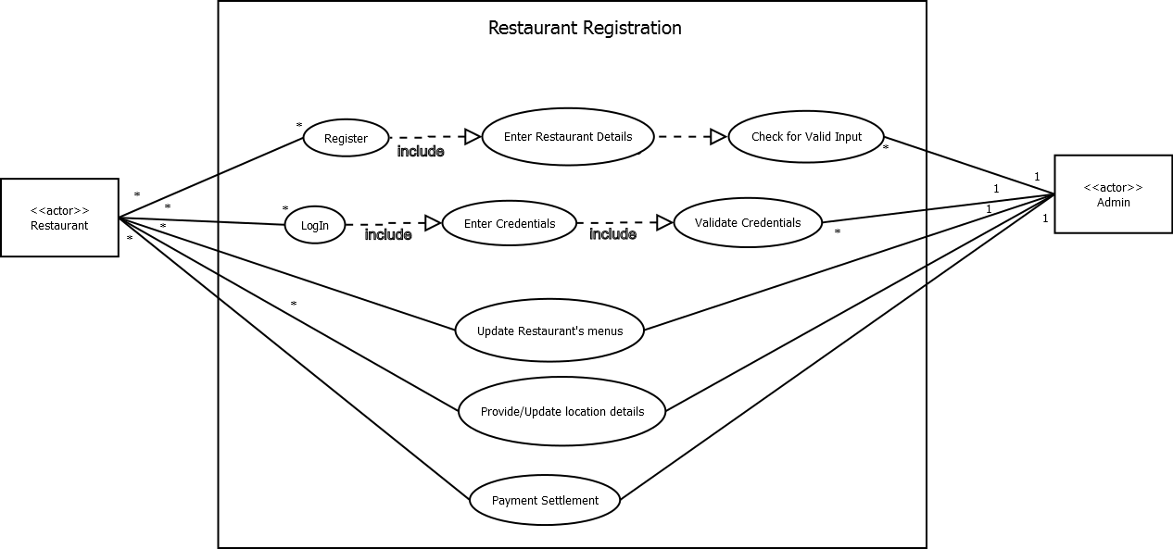

Use Case Description for Restaurant Registration:

Case Name: | Restaurant Registration
ID: | UC_3
Actors: | Admin, Restaurant(client)
Description: | The Restaurant manager register his restaurant in this app so that it could be available to the all users(customers)
Trigger: | The restaurant should be available all the time and should be subscribed by the manager
Relationships: | Association: User, System, App
Normal flow of Events: | - The restaurants will be displayed the based on rating and available items.  - Restaurant will register on the app and submitted to the admin and credentials will be given Restaurant manager so that he can add offers, prices and update menu items on the daily basis.  - The credentials will be validated by the system.  - Restaurant will be given rating based on their service provided.  - All payments to the restaurants were done once the order is placed by the customer.  - All restaurants should have an option of delivering the products and ready for pickups.  - It should be available for cash on delivery
Exceptions: | - The menu items stocks should be available online all the time.  - The distance from the customer to the restaurant should be managed well for a pickup or delivery

- Delivery System

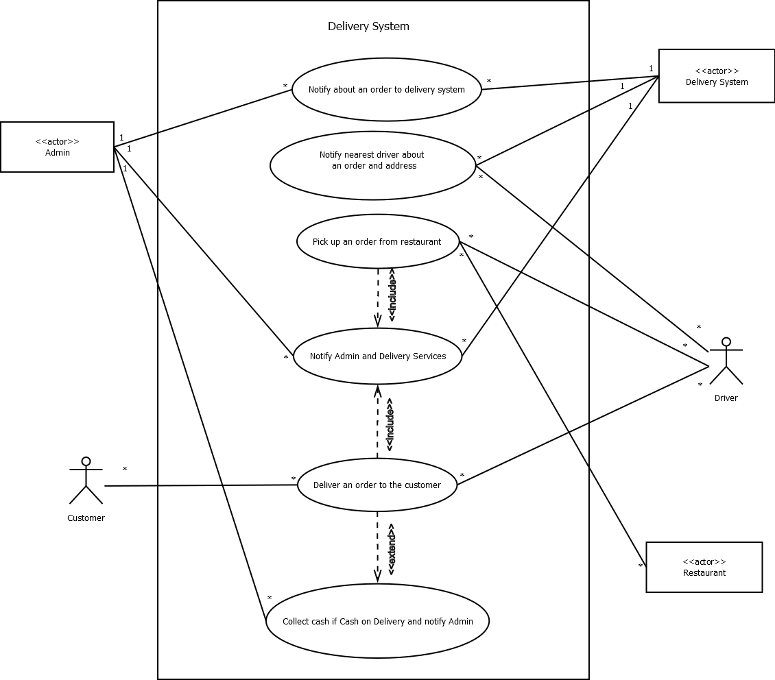

Use Case Description for Delivery of food:

Use case Name | Delivery of food
ID | UC_3
Primary Actor | Delivery Services
Stakeholder and Investor | Customer: wants to order a food.  Delivery services: wants to deliver a food.
Brief Description | This use case describe how delivery service deliver the food.
Trigger | While ordering food user has requested for home delivery.
Relationships | Association: Customer, Driver, Admin, Restaurant, Delivery System  Include: Picking up an order and delivering a food to customer will  include notifying Admin and Delivery System.  Exclude: Cash on delivery will depend on customer’s choice.  Generalization:
Normal flow of Events | - Admin will notify the Delivery system about an order  - Delivery system will notify the nearest driver about the order to pickup  - Driver will pick up the order from specified restaurant and notification will be sent to Admin and Delivery System.  - The Order will be delivered to customer and notification will be sent to Admin and Delivery System.
Sub flow
Alternate/Exceptional Flow | 4a. If cash on delivery, the Driver has to collect cash as indicated on the receipt.

Activity Diagram

1. Activity Diagram for Placing an Order:

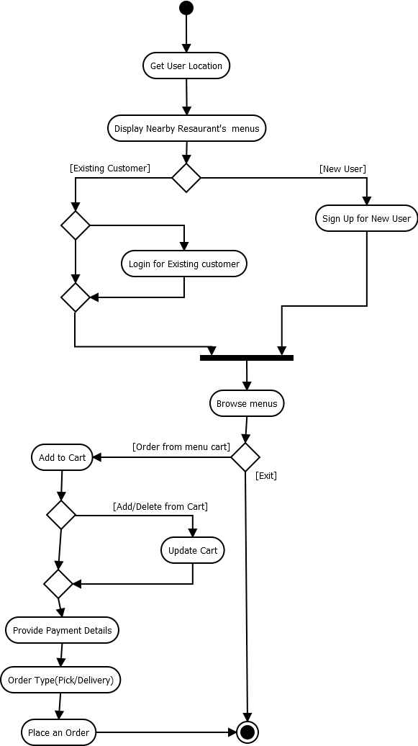

2. Activity Diagram for Restaurant and Delivery System:
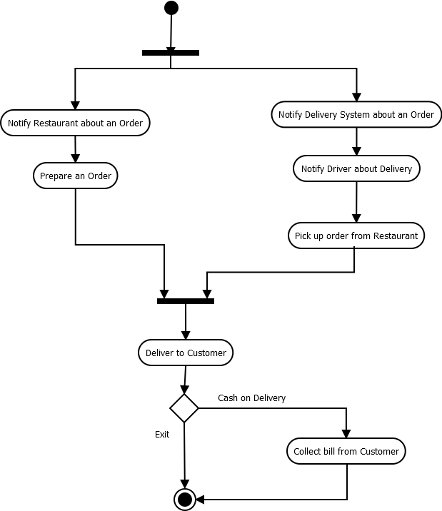

Sequence Diagram

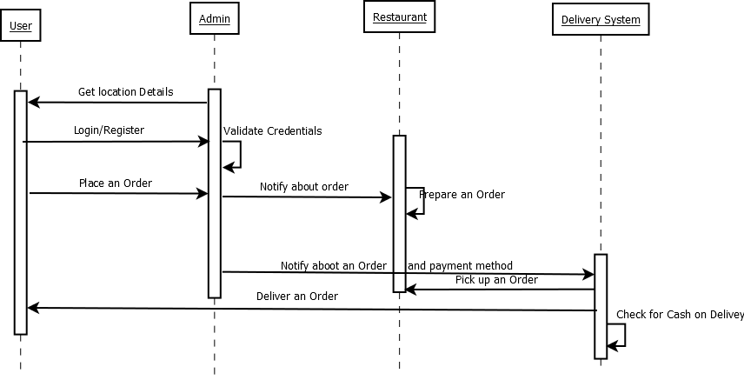

Class Diagram

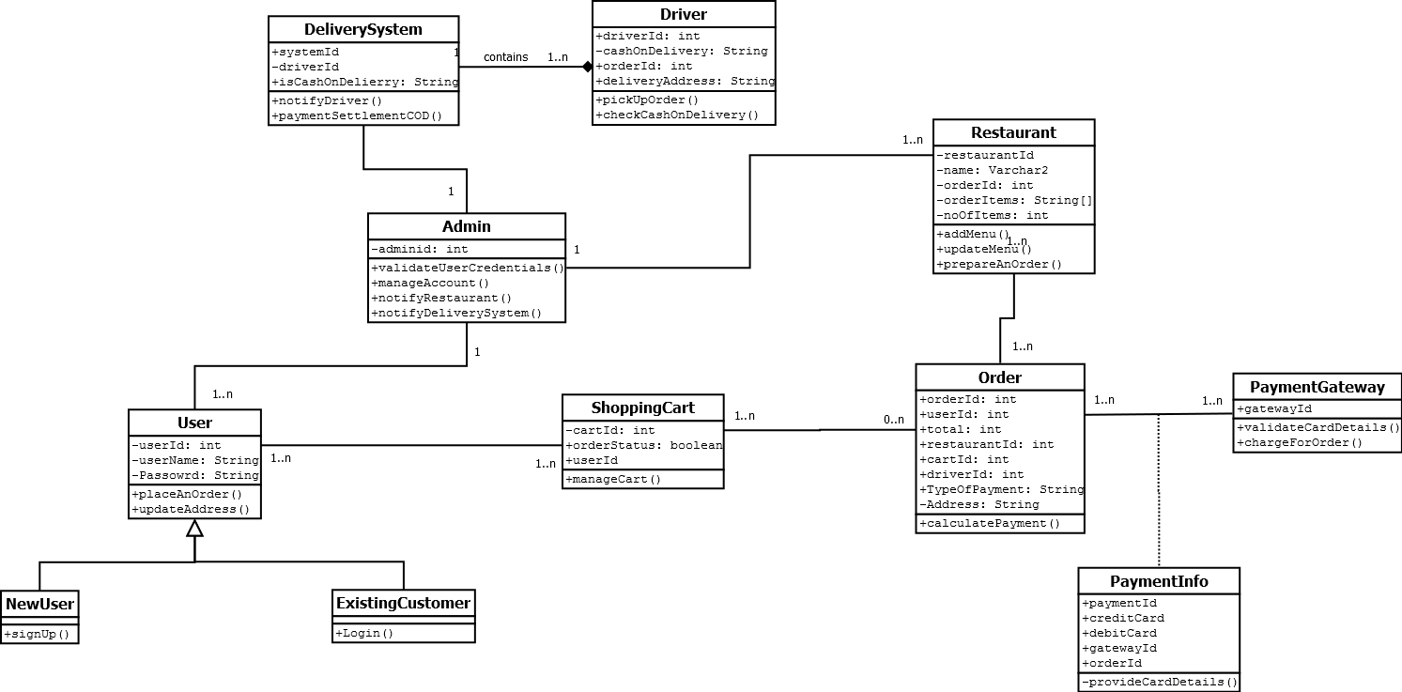

Object Diagram

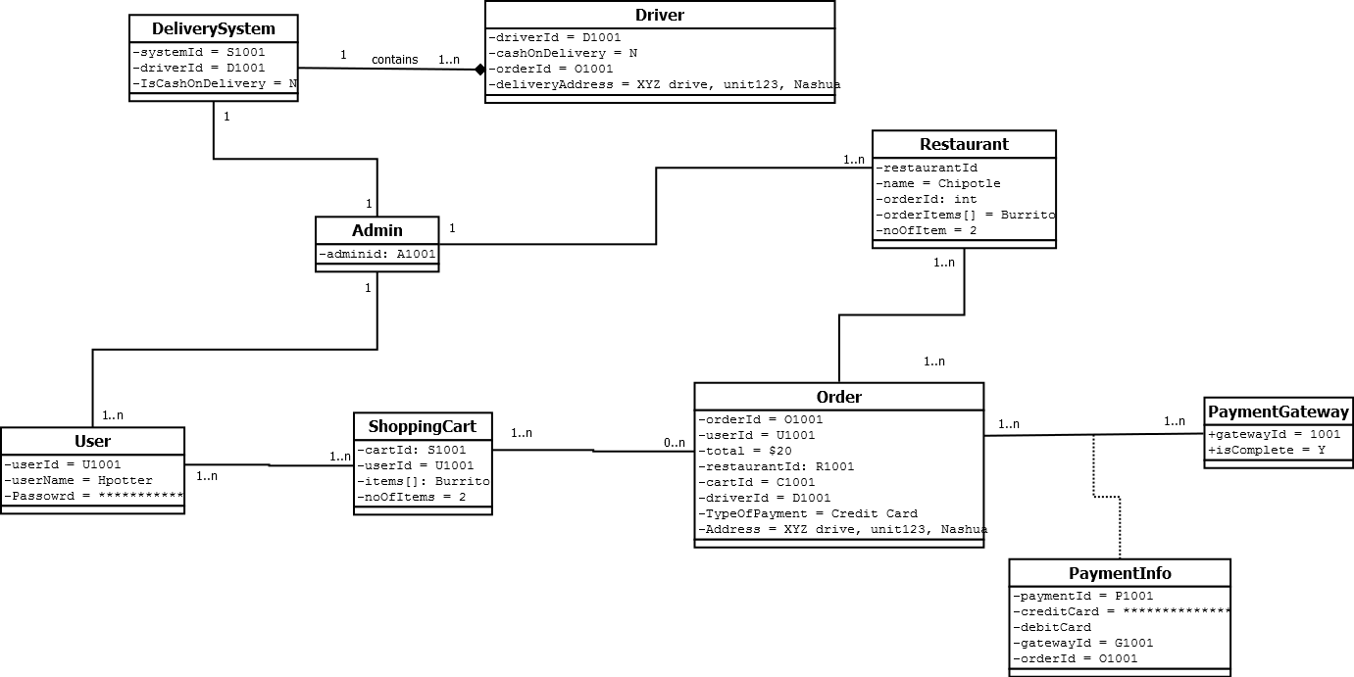

State Machine Diagram

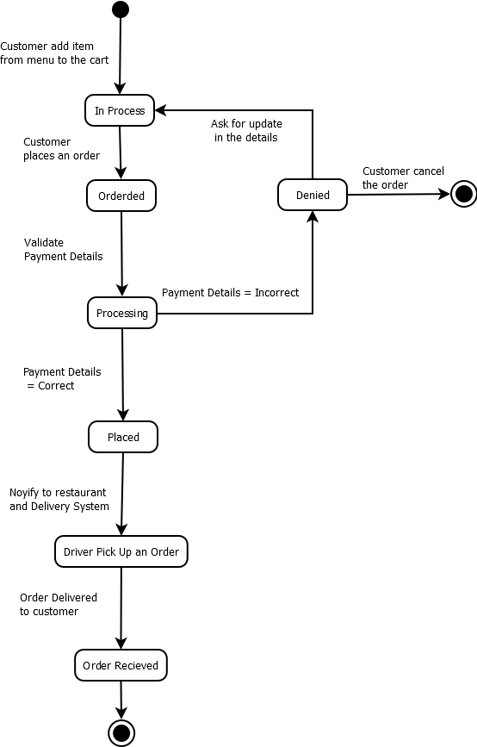

Functional Test Plan
It would include all the functional test cases for the project.
Test Cases:
This section will provide an idea about how the functionality work after the software be ready to use. The test cases provide what are the valid or invalid data input for particular feature. Based in the inputs of the user the respective response will get.

Login test case for both User and Restaurant Panel

Action | Input | Expected Output | Description
Valid Login | Username, Password | Navigated to next screen | User Successfully Login into Food Order app.
Invalid Login | Username, Password | Alert box with message “Invalid Credentials” and ask for credentials again | Unauthorized user trying to login.

Test Case for Admin Panel

Action | Input | Expected Output | Description
Orders Approval | Orders approved from user | List of Orders in Queue which are out for Delivery | Orders approved
Update Ads Restaurant | Upload from computer and click on upload. | Display the Ads on UI | Ads Updated successfully.
Feedback | Select the Accessories | Display Feedback by user so far. | Feedback Successfully
Payments bifurcation | Select the Orders separate bills | Payment online through banking | Transactions successfully.

Test Case for User Panel

Action | Input | Expected Output | Description
Search Restaurants | Select restaurant from the list | Menu items of nearest restaurant to farther restaurant | Store Display
Confirm Order | Select the restaurant and confirm Order | Display list of orders of menu items in checkout | Confirm Order Successfully.
Add Contact and Address | Before Transaction the user enters Shipping and mobile details for delivery | No output | Delivery Address details
Give Feedback | Select the restaurant and choose the food from it and add comments for that respective order. | Update the list with users add comment or queries regarding the Admin comment. | Updated Comments successfully.
Pickup | Create order pickup from store | pickup order should be ready for pickup | Pickup drive successfully done.

Test Case for Restaurant Panel

Action | Input | Expected Output | Description
Add Restaurant | Available food items in store | Display list of item available | Food available.
Delivery or Pickup | Selected the respective order check either pickup or delivery | There no specific output for this action. | Trigger a mail to customer and User regarding about “food is ready”
Give Feedback | Select the food and choose the option comments for that respective issue. | Positive feedback or negative feedback | Updated Comments successfully.
Bank transaction | Admin do the Transaction transfer the amount of cash individually for an order. | No output | Transaction will be done successfully.

System Design Specifications

System Physical Architectural

The Food Order App will need Three Tier Client-Server Architecture, as, it is an online mobile application.
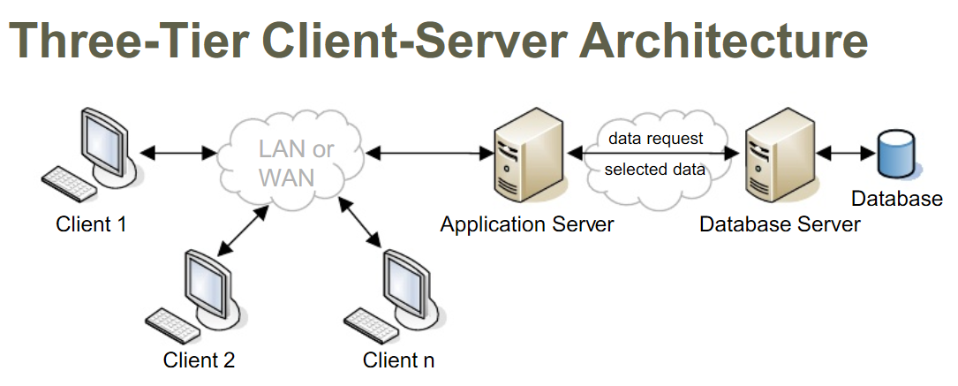
The above diagram describes how the Three Tier Client-Server Architecture will work. In the case of Food Order App clients will be the USER’s who installed app on the mobile phone and RESTAURANT’s who are registered for the app. Application Server will take care of the USER INTERFACE and Validations. Database Server will store all the data related to the application and will communicate with Application Server for validating all USER’s.

Package Diagram

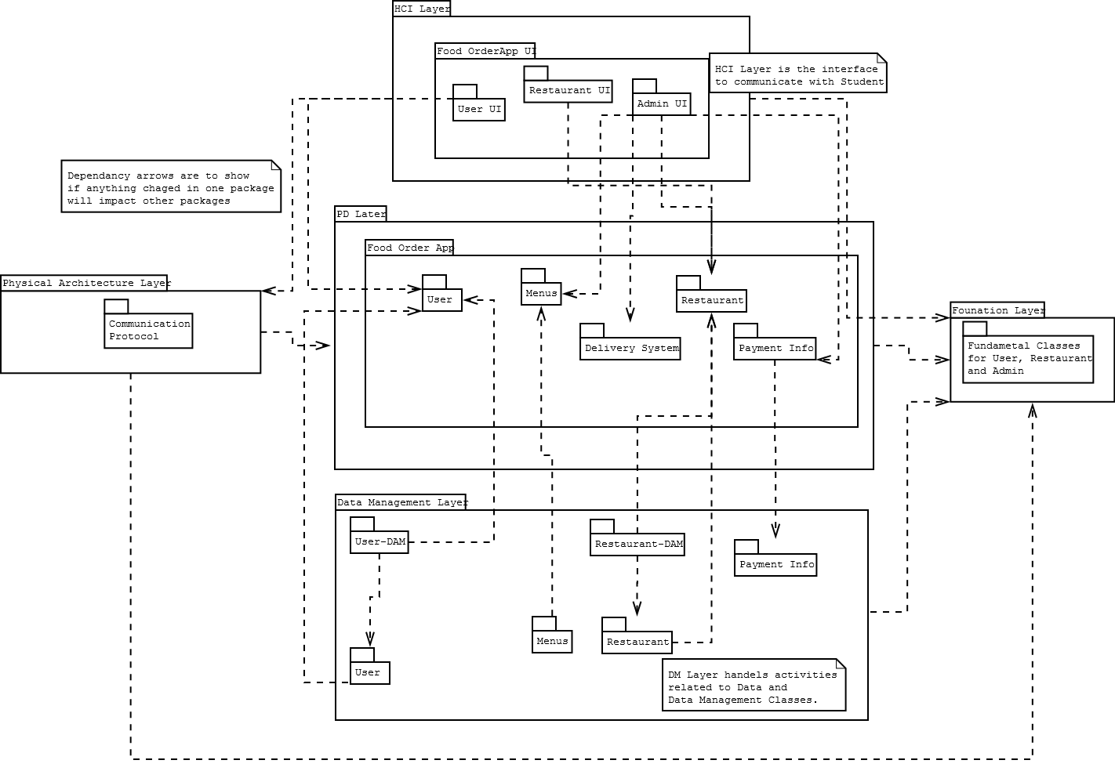

UI Design
Login/Register UI

Food Order App Login / Signup

Search Nearby Restaurants

Facebook / Twitter Feedback

User’s UI

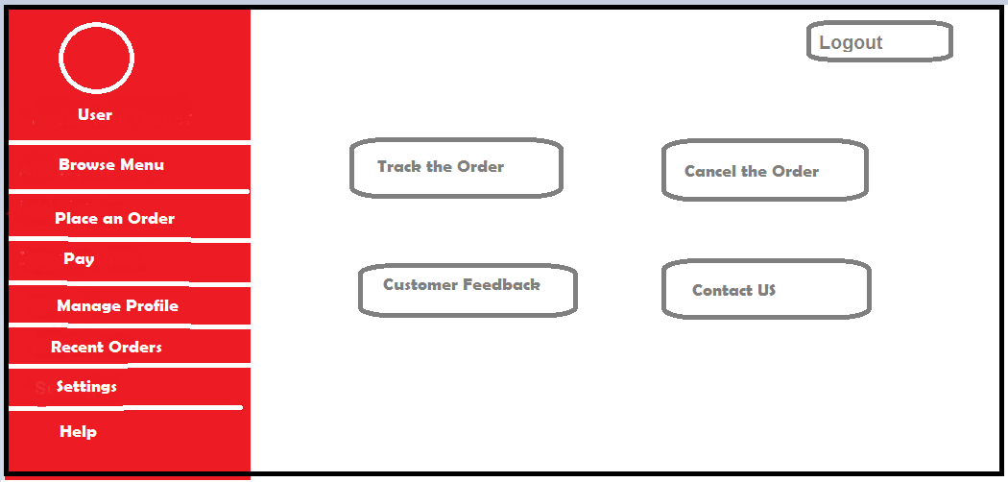

Admin UI

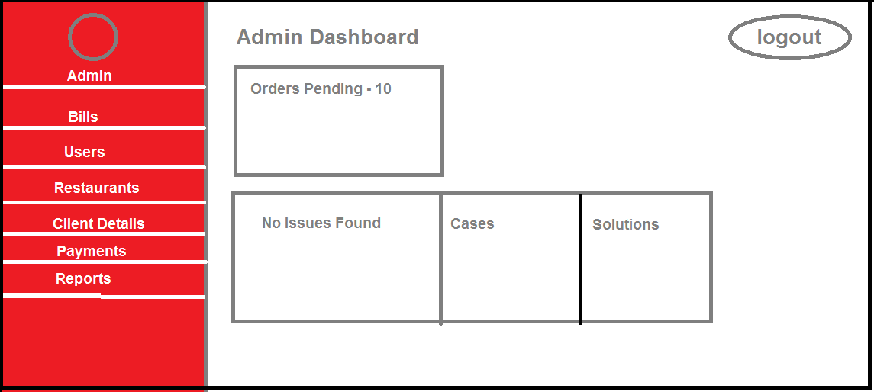

Restaurant UI

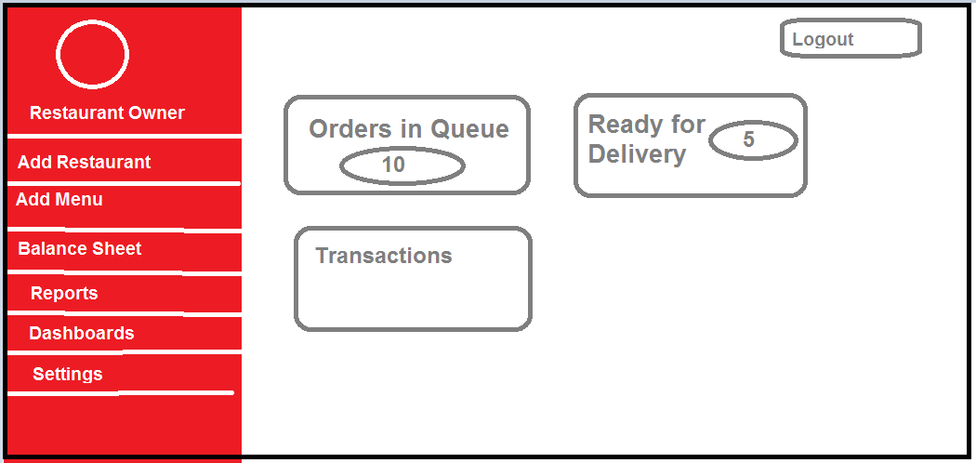

Window Navigation Diagram

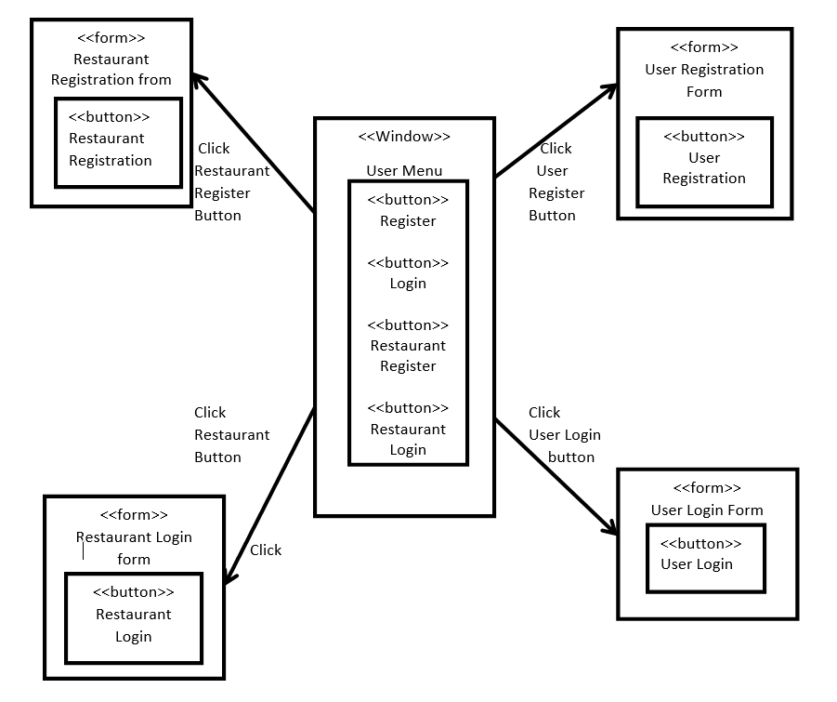

Database Structure

Table Structure
Below are some important table structures for the project:
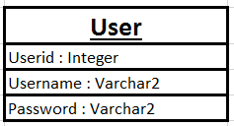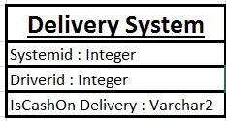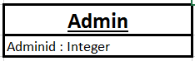
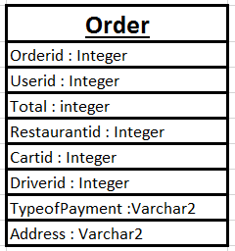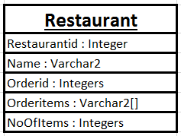

ER Diagram

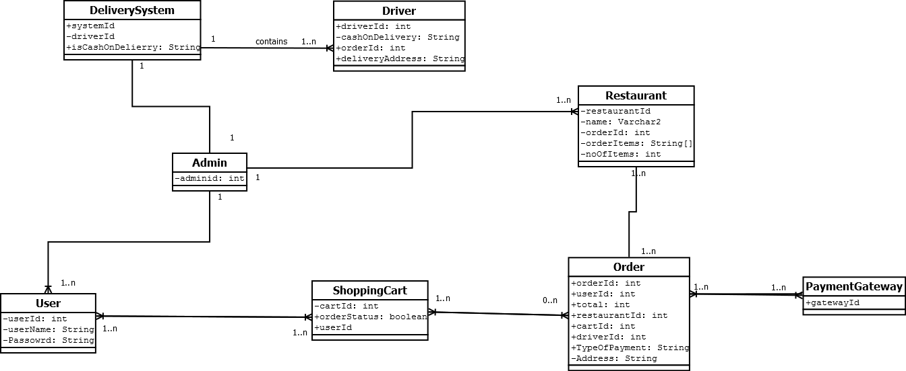

System Integration Test Plan
Below are the test cases which should be covered into system integration test plan, as they indicate how the system behaves when all components are put together.
Test case 1: User request for the order summary
Expected Output: App should display order summary by retrieving it from database
Test Case 2: User places an Order
Expected Output: Notification should be sent to Restaurant and Delivery System with all details
Test Case 3: User places an Order, Email notification test
Expected Output: Once the order has been placed, user should get email from the system.

Issues for future studies
The following project can be enhanced by adding below functionalities:
      - GPS system can be added into system, so the system can directly understand location of the user.
      - User should able to see the order status e.g. Order ready, Picked up by Driver etc.
      - The order data collected from the app can be used to analyze food preferences of an area.

Conclusion
Food Order App will give convenient approach for customer to browse an order food and for Restaurant to grow their market.

References
            - For project idea: https://www.foodler.com/
            - For System Physical Architectural
https://dbinfoworld.wordpress.com/2014/11/09/different-types-of-database-architecture/

